
MBARARA UNIVERSITY OF SCIENCE AND TECHNOLOGY
FACULTY OF COMPUTING AND INFORMATICS
DEPARTMENT OF COMPUTER SCIENCE
COURSE: DATABASE SYSTEMS
PROJECT TITLE: SALON MANAGEMENT SYSTEM (STAFF MODULE)
STUDENT NAME: MUYOMBYA ALLAN
REGISTRATION NUMBER: 2025/BCS/132/PS
LECTURER:MR.BAGUMA KENNETH

1. EXECUTIVE SUMMARY
In the contemporary business environment, the efficiency of service-based enterprises like hair salons depends heavily on the reliable management of data. This project details the development of a Staff Management Module for a Salon Management System. The primary objective of this system is to transition from manual, paper-based record-keeping to a centralized, relational database using MySQL.
The report covers the entire development lifecycle: starting with a comprehensive business case that justifies the system's economic and operational feasibility, moving into a logical design that maps out entities like Staff, Roles, and Shifts, and concluding with a physical implementation. Through the use of structured queries, the system demonstrates how a salon can automate commission calculations, optimize staff scheduling, and maintain high data integrity. This project serves as a practical application of database normalization and relational algebra to solve real-world business challenges.

2. BUSINESS CASE
2.1 The Application Domain
The application domain for this project is the retail service sector, specifically a professional beauty salon. In this environment, the "Staff" are the primary revenue generators. Managing them involves tracking complex variables such as different skill sets (specializations), varying pay scales, and rotating work shifts.
Tasks Supported:
Personnel Tracking: Maintaining up-to-date records of contact info, hire dates, and roles.
Scheduling: Assigning staff to specific time blocks (Shifts) to ensure the salon is never understaffed during peak hours.
Financial Management: Tracking base salaries and commission rates to ensure accurate monthly payouts.
Performance & Skill Tracking: Recording certifications and monitoring daily attendance logs.
User Groups:
Administrator/Manager: Responsible for hiring, role assignment, and payroll oversight.
Front-Desk Receptionist: Needs to view staff availability to book customer appointments accurately.
General Staff: Need to view their assigned shifts and understand their performance metrics.
2.2 Analysis of Benefits
Tangible Benefits:
Payroll Accuracy: Automated calculation of commissions based on fixed rates stored in the database reduces human error by 100%.
Time Efficiency: Managers save approximately 5–10 hours per week that were previously spent manually cross-referencing paper rosters.
Revenue Growth: By tracking staff specializations, the salon can book more high-value services by ensuring the right staff are present.
Intangible Benefits:
Employee Satisfaction: Clear, transparent records of work hours and earnings reduce workplace disputes.
Professionalism: A digital system improves the salon's brand image in the eyes of customers.
2.3 Analysis of Costs
Hardware Costs: Use of existing salon computers for local hosting. Estimated maintenance cost of 200000 UGX or slightly more depending on the salon.
Software Costs: MySQL is open-source (Free), significantly reducing the project's financial burden.
Development & Training: The primary cost is the time spent by the developer and the time spent training staff to use the new interface.
2.4 User Issues
The adoption of this system requires staff to move away from traditional "notebook" scheduling. Key issues include:
Technical Literacy: Some senior stylists may require hands-on workshops to become comfortable with digital data entry.
Adoption Effort: To ensure success, the system must be more convenient than the paper alternative. This is achieved through a simplified user interface.
2.5 Risk Assessment
Data Vulnerability: Without a backup strategy, a system crash could wipe out payroll history.
Privacy Risk: Storing personal phone numbers and salary data requires strict access controls so staff cannot see each other's private information.
2.6 Limitations of the System
The system currently handles staff and schedules but does not include a full "Point of Sale" (POS) hardware integration for credit card processing.
It does not automatically calculate government taxes (PAYE) or social security (NSSF) contributions, which must still be handled by an accountant using the data exported from this system.

3. DESIGN: LOGICAL AND PHYSICAL
3.1 List of Entities and Attributes
Staff: StaffID (PK), FirstName, LastName, Email, Phone, HireDate, Specialization, RoleID (FK).
Roles: RoleID (PK), RoleTitle, BaseSalary, CommissionRate.
Shifts: ShiftID (PK), DayOfWeek, StartTime, EndTime.
Staff_Schedules: ScheduleID (PK), StaffID (FK), ShiftID (FK), DateAssigned.
Skills: SkillID (PK), SkillName, Description.
Staff_Skills: StaffID (FK), SkillID (FK), CertificationDate.
Attendance: AttendanceID (PK), StaffID (FK), WorkDate, ClockIn, ClockOut, Status.
Leave_Requests: LeaveID (PK), StaffID (FK), StartDate, EndDate, LeaveType, ApprovalStatus.
3.2 Data Dictionary (Technical Specification)
Table | Column | Data Type | Description
Staff | StaffID | INT | Primary Key, Auto-incremented
 | FirstName | VARCHAR(50) | Staff's given name
 | Email | VARCHAR(100) | Unique contact address
Roles | RoleTitle | VARCHAR(50) | Position name (e.g., Senior Barber)
 | BaseSalary | DECIMAL(10,2) | Monthly fixed payment
Shifts | DayOfWeek | VARCHAR(15) | Monday, Tuesday, etc.
Attendance | ClockIn | TIME | Actual arrival time
 | Status | VARCHAR(20) | 'Present' or 'Late'
Skills | SkillName | VARCHAR(50) | e.g., 'Bridal Styling'

3.3 Entity Relationships (Multiplicities)
Staff to Roles: A Many-to-One relationship. Many employees can hold the same role, but one employee is assigned to exactly one primary role.
Staff to Shifts: A Many-to-Many relationship. Resolved via the bridge table Staff_Schedules.
Staff to Skills: A Many-to-Many relationship. One staff has many skills, one skill is held by many staff. This is resolved via Staff_Skills.
Staff to Attendance: A One-to-Many relationship. One staff member has many daily logs.
3.4 Dialogue Structure (User Interface)
The system follows a hierarchical dialogue path:
Login Prompt requires Input Staff Credentials.
Main Menu to Options: [View Roster], [Employee Directory], [Payroll Report], [Skill Matrix].
3.41 The Employee Record Management Path is shown below:
This dialogue path facilitates deep-dive administrative actions on individual staff records. The logic follows a three-step drill-down approach.
Employee Record -> Select Staff ->Edit Specialization/View Attendance.

3.5 ER Diagram.

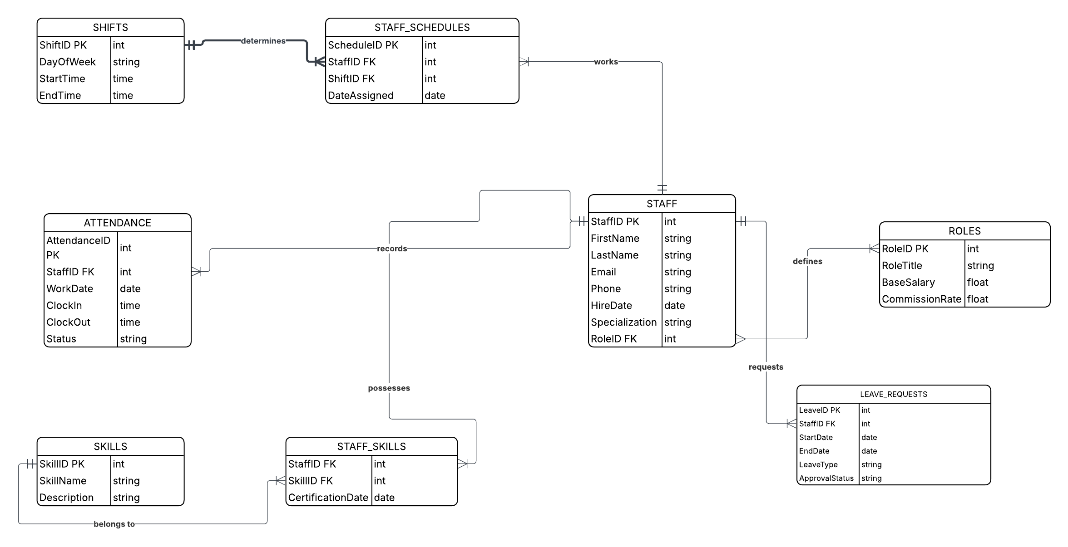
3.5.1 Technical Analysis of the ER Diagram
The Entity Relationship Diagram presented above represents a comprehensive, normalized data model for the Salon Staff Management Module. The design adheres to the principles of the Third Normal Form (3NF) to ensure data consistency and eliminate operational anomalies. The following technical logic was applied to the design:
A. The Staff and Roles
The relationship between the ROLES and STAFF entities is a One-to-Many (1:N) relationship. The ROLES table acts as a parent lookup table containing fixed metadata such as BaseSalary and CommissionRate.
Referential Integrity: This is enforced by the RoleID Foreign Key in the STAFF table.
Multiplicity: The design utilizes Mandatory Multiplicity. This ensures that no staff record can be created in the system without an associated role, preventing personnel records with no defined salary structure.
B. The Shifts and Staff_Schedules
The system manages operational hours through a Many-to-Many (M:N) relationship between STAFF and SHIFTS. In database design, M:N relationships cannot be directly implemented in a relational schema. Therefore, I resolved this using an Associative Entity called STAFF_SCHEDULES.
Logic: One stylist can work many shifts throughout the week, and one shift (e.g., "Saturday Morning") can be assigned to multiple stylists.
The Bridge: The STAFF_SCHEDULES table uses StaffID and ShiftID as composite identifiers to track exactly who is working on a specific DateAssigned.
C. The Skills and Staff_Skills.
To facilitate specialized service booking (e.g., Bridal Styling), the system tracks professional certifications through another Many-to-Many relationship between STAFF and SKILLS.
Resolution: I implemented a second bridge table, STAFF_SKILLS. This allows the salon manager to audit the workforce’s capabilities.
Attributes: This bridge table includes a CertificationDate attribute, which provides a historical record of when a stylist acquired a specific skill, adding a layer of professional accountability to the database.
D. Attendance and Leave
The ATTENDANCE and LEAVE_REQUESTS tables are linked to the STAFF entity via One-to-Many (1:N) relationships.
Punctuality Tracking: The ATTENDANCE table is a transaction-heavy entity that logs daily arrival and departure times.
HR Logic: The LEAVE_REQUESTS table includes a Status attribute with a default value of 'Pending'. This represents a business workflow, where data remains in a temporary state until a manager updates the record to 'Approved' or 'Denied'.
3.5.2 Summary of Integrity Constraints
Throughout the diagram, Crow’s Foot Notation is used to provide a visual map of the schema’s constraints.
Primary Keys (PK): Every entity has a unique, non-null identifier using auto_increment to ensure that every record is different.
Foreign Keys (FK): These are strategically placed in child tables to maintain a strict relational hierarchy.
Domain Integrity: Data types such as DECIMAL for financial accuracy and TIME for scheduling precision ensure that the system reflects real-world operational requirements.
4. IMPLEMENTATION (MySQL)
4.1 Physical Design & Schema Creation.
The following Data Definition Language scripts were executed in the shell to create the 8 tables, enforcing referential integrity through foreign key constraints as shown in mysql screenshots below. 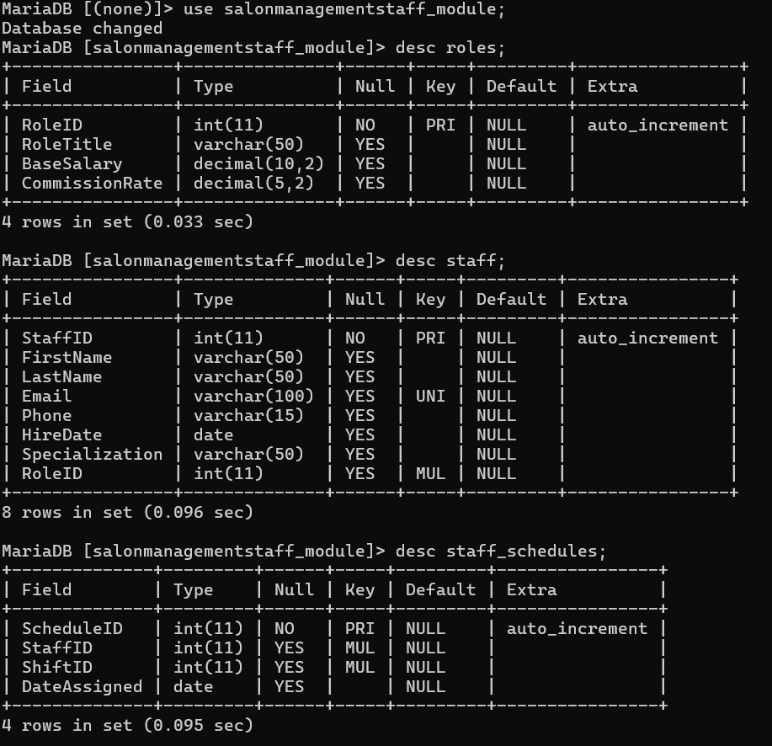
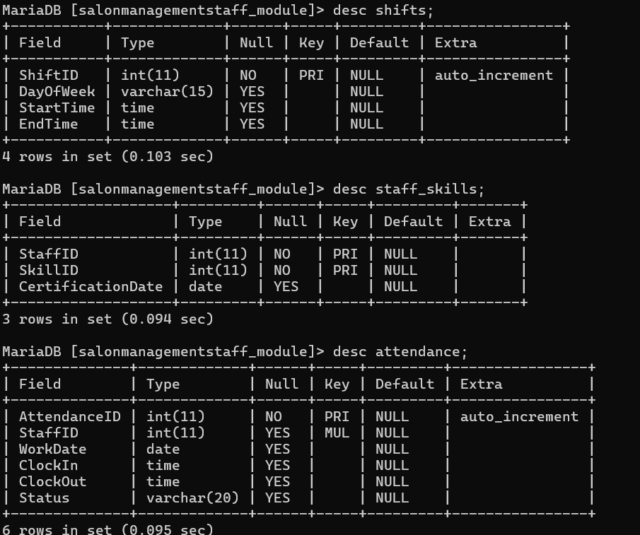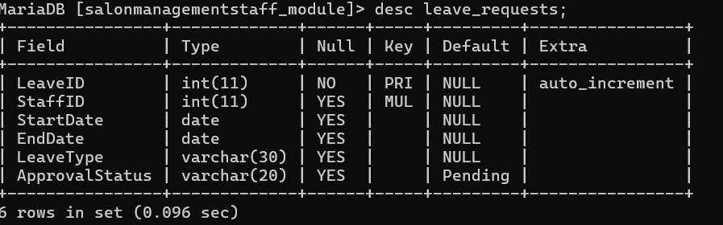

4.2 Data Population (DML)
The system was populated with a realistic dataset to test the operational logic.
Below are the sample screenshots showing populated tables with data.
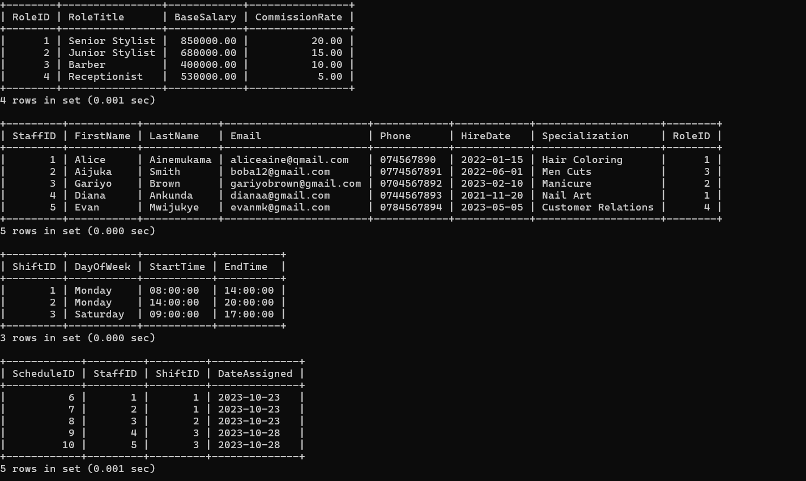

5. SAMPLE QUERIES AND RESULTS

5.1 Advanced Relational Queries
The following queries demonstrate the system's ability to turn raw data into business intelligence.
Query 1: Skill Matrix Join (Finding Specialists)
SELECT s.FirstName, sk.SkillName, ss.CertificationDate FROM Staff sJOIN Staff_Skills ss ON s.StaffID = ss.StaffIDJOIN Skills sk ON ss.SkillID = sk.SkillID WHERE sk.SkillName = 'Dreadlocking';
Query 2: Payroll Expenditure Forecast
SELECT r.RoleTitle, COUNT(s.StaffID) AS Total_Staff, SUM(r.BaseSalary) AS Monthly_Pay FROM Roles rJOIN Staff s ON r.RoleID = s.RoleIDGROUP BY r.RoleTitle;

Query 3: Monitoring Punctuality.

SELECT s.FirstName, s.LastName, a.WorkDate, a.ClockIn, a.Status FROM Staff s JOIN Attendance a ON s.StaffID = a.StaffID WHERE a.ClockIn > '08:00:00';

5.2 The above queries were inplementented in my sql shell as shown in the screenshot attached below.
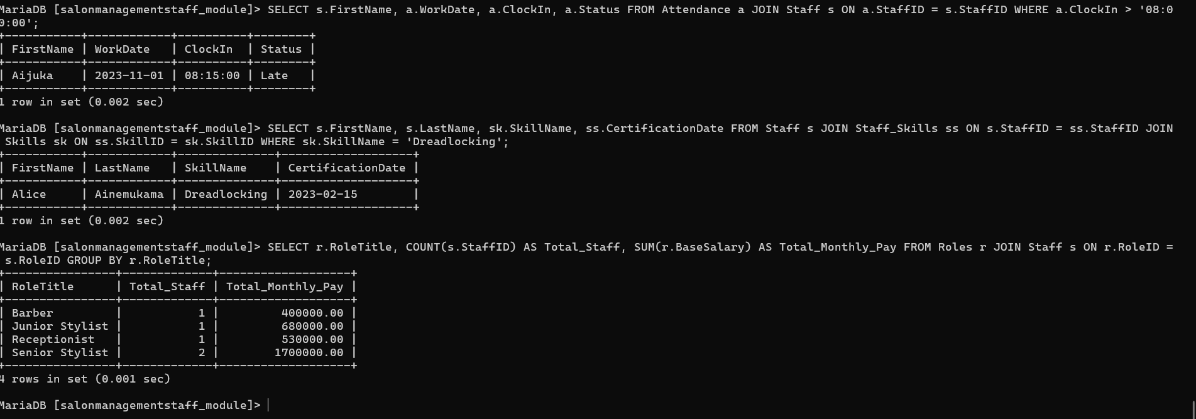

6. COMPARABLE SYSTEM ANALYSIS
During the design phase, I benchmarked the Staff Module against Fresha and Squire, which are global leaders in salon management. From this research, I learned that professional systems use Competency-based Scheduling. I adapted this by creating the Staff_Skills bridge table, ensuring that the salon can identify specialists for specific customer requests. This makes my module highly scalable compared to a simple list-based staff system.

7. BIBLIOGRAPHY
- Coronel, C., & Morris, S. (2018). Database Systems: Design, Implementation, & Management (13th ed.). Cengage Learning. https://www.cengage.com/c/database-systems-design-implementation-management-13e-coronel/
- Elmasri, R., & Navathe, S. B. (2017). Fundamentals of Database Systems (7th ed.). Pearson. https://www.pearson.com/en-us/subject-catalog/p/fundamentals-of-database-systems/P200000003310
- Fresha Software. (2024). Professional Salon Management: Staff & Skills Matrix. https://www.fresha.com/for-business
- Squire Barbershop Platform. (2024). Barbershop Analytics and Commission Tracking. https://www.getsquire.com/

